Chapter 19, Problem 94.

A transistor in its common-emitter mode is specified by

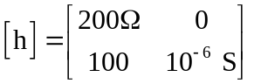

Two such identical transistors are connected in cascade to form a two-stage amplifier used at audio frequencies. If the amplifier is terminated by a 4-kΩ resistor, calculate the overall A_{v} and Z_{in}.

